Monthly Performance Report – August 2025
Kestrel Ridge Wind Farm (75.6 MW)
David Chen · 09 September 2025 · KR-OPS-RPT-2025-08

1. Summary
Kestrel Ridge generated 12.3 GWh in August 2025, 2.4 % below the P50 budget of 12.6 GWh. Time-based availability was strong at 97.6 % (contract target 97.0 %). Mean hub-height wind speed of 6.9 m/s was close to the long-term mean (6.9 m/s). Compared with August 2024 (13.6 GWh), output was down 1.3 GWh.

2. Production and key figures
KPI | August 2025 | Budget / target | YTD 2025 | YTD budget
Net generation (GWh) | 12.3 | 12.6 | 127.3 | 133.6
Time-based availability | 97.6 % | 97.0 % | 97.3 % | 97.0 %
Capacity factor | 21.9 % | 22.4 % | 28.9 % | –
Mean wind speed at hub height (m/s) | 6.9 | 6.9 | – | –
Source: Kestrel Ridge SCADA, revenue meter at 132 kV point of connection. Budget = P50 (2024 post-construction yield assessment).
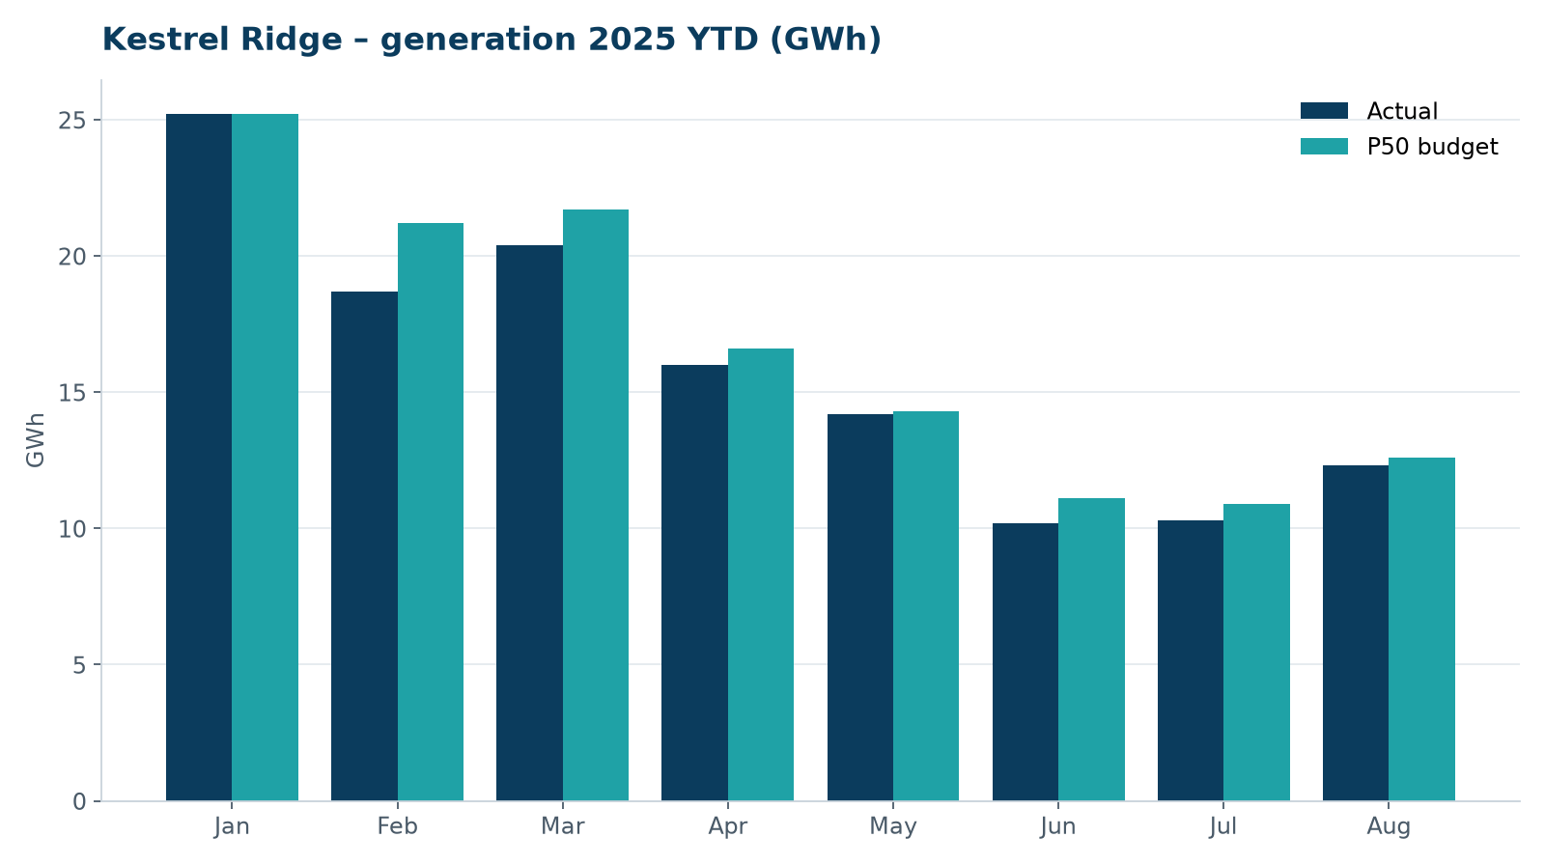
Monthly generation vs. P50 budget, 2025 year to date

3. Availability and downtime
Total turbine downtime attributable to the contractor amounted to 32 turbine-hours for the top events listed below. No grid or force majeure exclusions were claimed this month.
Turbine | Event | Downtime (h)
T-15 | nacelle cooling fan motor failure | 18
T-16 | anemometer heater failure – sensor replaced | 5
T-18 | high-voltage transformer gas relay alarm (inspected, no fault found) | 5
T-16 | tower base controller communication loss | 4
Top downtime events of the month (SCADA event log, reviewed with Highline Wind Services).

4. Maintenance
- Annual service: 2 turbines completed this month.
- 18 corrective work orders closed, 3 still open at month end.
- Monthly safety equipment checks (fall arrest, rescue kits, fire extinguishers) completed on all towers.

5. Health, safety and environment
Indicator | Month
Hours worked on site (Highline + Weyland) | 3,628
Lost time injuries | 0
First aid cases | 0
Near misses reported | 1
Safety observations | 14
Environmental incidents | 0

No environmental incidents. Bird carcass searches were carried out on schedule (fortnightly, all turbines).

6. Outlook
We will review the downtime events above with Highline in the monthly O&M meeting and track the recurring pitch faults.
Prepared by Sara Lindgren (Performance Analyst); reviewed by Ben Okoye (Site Manager) and David Chen (Asset Operations Manager).

